Solution Design Document – HealthCare Insurance Data Analytics System

Solution - The solution is an end-to-end data analytics pipeline built for a Healthcare Insurance Company. The pipeline collects raw data, cleans it, processes it and stores the results in AWS Redshift so that business teams can easily access and use the data. The solution is designed as an end-to-end data pipeline and is implemented in the following steps:

Step 1 : Data Collection
Raw data files including Patients, Subscribers, Claims, Group Subgroup and Hospitals are collected from web scraping and third-party sources and uploaded to AWS S3 in a folder called input-data.
- Step 2 : Data Reading and Development
PySpark code is written and tested on Databricks Community Edition. PySpark reads all raw data files from AWS S3 and loads them into PySpark DataFrames for processing.
- Step 3 : Data Cleaning
The system checks each dataset for null values and counts the total null values for each column. Null values in specific columns are then replaced with NA. The system also identifies and removes duplicate records. This cleaning is applied to Patients, Subscribers, Claims and Group Subgroup datasets. This ensures that only clean and accurate data moves forward in the pipeline.
- Step 4 : Storing Cleaned Data
The cleaned datasets are written to AWS Redshift tables so they are stored safely and can be used for analysis.
- Step 5 : Data Processing and Result Generation
PySpark processes and joins the cleaned datasets to answer all 13 business use cases. Each result is stored in a separate table in the Project-Output schema in AWS Redshift.
- Step 6 : Deployment
Once the code is tested and validated on Databricks it is pushed to GitHub using PyCharm for storing and version control. The code is then deployed to AWS EMR Studio or Databricks from GitHub for production execution.

- Use Cases - The following are the 13 business use cases that this solution will address. Each use case will have a separate result table stored in the Project-Output schema in AWS Redshift:
- Find the disease with the maximum number of claims
- Find subscribers with age less than 30 who subscribe to any subgroup
- Find which group has the maximum number of subgroups
- Find the hospital that serves the most number of patients
- Find which subgroup is subscribed the most number of times
- Find the total number of claims that were rejected
- Find the city from which the most claims are coming
- Find which group subscribers prefer most — Government or Private
- Calculate the average monthly premium paid by subscribers
- Find which policy group is the most profitable
- List all patients below age 18 admitted for cancer
- List patients with cashless insurance and total charges greater than or equal to Rs. 50,000
- List female patients over age 40 who had knee surgery in the past year

- Database Design – This section lists all the Redshift database tables used in the Healthcare Insurance Data Analytics System. The tables are divided into two groups:
- The first group contains the cleaned data tables stored in the public schema. These tables hold the cleaned and processed data for Patients, Subscribers, Claims, Group Subgroup and Hospitals.
- The second group contains the result tables stored in the Project-Output schema. These tables hold the results of all 13 business use cases generated by the pipeline.
Each table is described with its column names, data types and Primary Key and Foreign Key relationships so that the database structure is clear and easy to understand.

For better understanding:
- Tables with suffix _clean represent cleaned and processed data.
- Tables with prefix out_ represent the final output results for business use cases.
Cleaned Source Tables (public schema):
- claims_clean
- patient_records_clean
- subscriber_clean
- hospital_clean
- group_clean
- subgroup_clean
- grpsubgrp_clean
- disease_clean
Output Tables (Project-Output schema):
- out_max_claim_disease
- out_subscribers_age_lt_30_subgroup
- out_group_max_subgroups
- out_hospital_max_patients
- out_most_subscribed_subgroup
- out_total_rejected_claims
- out_claims_max_city
- out_group_preference_gov_private
- out_avg_monthly_premium
- out_most_profitable_group
- out_patients_below_18_cancer
- out_cashless_high_charge_patients
- out_female_40plus_knee_surgery
This structure ensures that data is organized, easy to query, and supports all business use cases.

Tables Metadata Info with Pk/FK relationship - The following tables describe the structure of each Redshift table including column names, data types and Primary Key and Foreign Key relationships:

- Table Name: claims_clean
Purpose: Stores cleaned claim details used for claim analysis and business reporting.
Column Name | Data Type | Key | Description
claim_id | INT | PK | Unique identifier for each claim
patient_id | INT | FK | Links the claim to a patient
sub_id | VARCHAR(20) | FK | Links the claim to a subscriber
disease_name | VARCHAR(100) | - | Disease for which the claim was raised
claim_or_rejected | VARCHAR(10) | - | Shows whether the claim was approved or rejected
claim_type | VARCHAR(50) | - | Type of claim
claim_amount | DECIMAL(10,2) | - | Amount claimed
claim_date | DATE | - | Date of the claim
Primary Key:
- claim_id
Foreign Key Relationships:
- patient_id references patient_records_clean.patient_id
- sub_id references subscriber_clean.sub_id

- Table Name: patient_records_clean
Purpose: Stores cleaned patient details used for analysis and linking with claims and subscriber data.
Column Name | Data Type | Key | Description
patient_id | INT | PK | Unique identifier for each patient
patient_name | VARCHAR(100) | - | Name of the patient
gender | VARCHAR(10) | - | Gender of the patient
age | INT | - | Age of the patient
city | VARCHAR(50) | - | City of the patient
Primary Key:
- patient_id
Foreign Key Relationships:
- None
- Table Name: subscriber_clean
Purpose: Stores cleaned subscriber details used for policy analysis and linking with claims and group data.
Column Name | Data Type | Key | Description
sub_id | VARCHAR(20) | PK | Unique identifier for each subscriber
patient_id | INT | FK | Links subscriber to patient
group_id | INT | FK | Links subscriber to policy group
subgroup_id | INT | FK | Links subscriber to subgroup
age | INT | - | Age of the subscriber
monthly_premium | DECIMAL(10,2) | - | Monthly premium paid by subscriber
Primary Key:
- sub_id
Foreign Key Relationships:
- patient_id references patient_records_clean.patient_id
- group_id references group_clean.group_id
- subgroup_id references subgroup_clean.subgroup_id

- Table Name: hospital_clean
Purpose: Stores cleaned hospital details used for hospital-wise patient and claim analysis.
Column Name | Data Type | Key | Description
hospital_id | INT | PK | Unique identifier for each hospital
hospital_name | VARCHAR(100) | - | Name of the hospital
city | VARCHAR(50) | - | City where the hospital is located
state | VARCHAR(50) | - | State where the hospital is located
hospital_type | VARCHAR(50) | - | Type or category of hospital
Primary Key:
- hospital_id
Foreign Key Relationships:
- None
The detailed metadata for the main transactional tables is provided above, while supporting master tables are listed in short format for simplicity.
Other Supporting Tables
Table Name: group_clean
Columns: group_id (PK), group_name
Table Name: subgroup_clean
Columns: subgroup_id (PK), subgroup_name
Table Name: grpsubgrp_clean
Columns: grp_subgrp_id (PK), group_id (FK), subgroup_id (FK)
Table Name: disease_clean
Columns: disease_id (PK), disease_name
Foreign Key Relationships:
- group_id references group_clean.group_id
- subgroup_id references subgroup_clean.subgroup_id

ER diagram – The ER diagram represents the structure of the database and shows how different tables are connected using Primary Key (PK) and Foreign Key (FK) relationships.
In this design, the main focus is on the transactional flow of data:
- The claims_clean table is the central table, which stores all claim-related information. It is connected to:
  - patient_records_clean using patient_id
  - subscriber_clean using sub_id
- The subscriber_clean table connects business-related data. It links:
  - to patient_records_clean using patient_id
  - to group_clean using group_id
  - to subgroup_clean using subgroup_id
- The grpsubgrp_clean table acts as a mapping table between group_clean and subgroup_clean, showing how groups and subgroups are related.
- The patient_records_clean table stores patient details and is referenced by both claims and subscriber tables.
- The group_clean and subgroup_clean tables store master data for policy grouping.
- The hospital_clean and disease_clean tables are independent tables that store supporting information and are not directly connected through foreign keys in this design.
Overall, the ER diagram helps in understanding the data flow, relationships between tables, and ensures that the database is structured in a way that supports all business use cases efficiently.
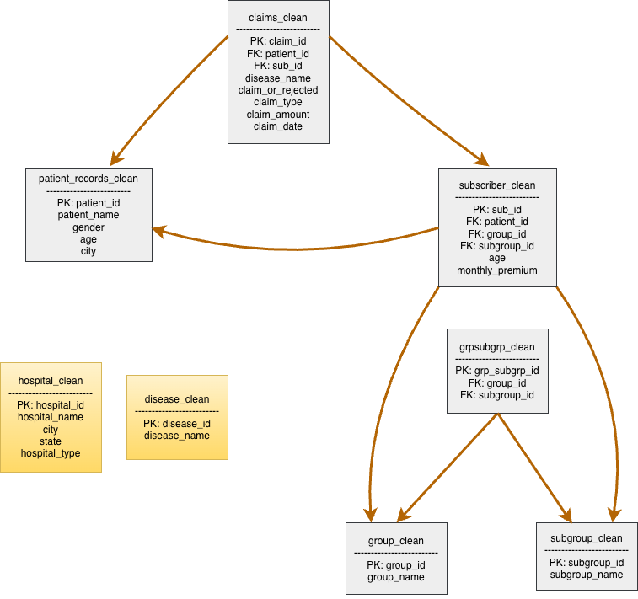

Figure: ER Diagram of Healthcare Insurance Data Analytics System

Technologies and Systems to be used in this solution - The following technologies and systems are used to build and run the Healthcare Insurance Data Analytics System:
- AWS S3 – Used to store raw input data files such as claims, patients, and subscribers.
- AWS Redshift – Used as the data warehouse to store cleaned data and the final output tables for all business use cases.
- AWS EMR Studio – Used to run large-scale PySpark jobs for processing data in the production environment.
- Databricks – Used during development to write, test, and run PySpark code.
- PySpark – Used to process large volumes of data, perform data cleaning, and generate results for all use cases.
- Python – The main programming language used to write all data processing scripts and modules.
- JDBC Driver – Used to connect PySpark with AWS Redshift for reading and writing data.
- GitHub – Used to store and manage all project source code and documents.
- Jira – Used to manage project tasks, track progress, and organize sprint activities.
- PyCharm – Used as the development tool to write Python code and push it to GitHub.
These technologies work together to build a complete end-to-end data pipeline that supports data ingestion, processing, storage, and analysis.

